 **Introduction to Computer Programming for Data Science**

**Week 7**

**________________________________________________________________________**

**Learning Outcomes:**

* Students should be able to think logically and develop problem-solving skills
* Students should be able to define repetitive statements
* Students should be able to define repetitive structure on user choice
* Students should be able to design structure to reduce the number of statements.
* Objective(s): To understand the programming using Loop Statements (for, while)

**Instructions**

• Use proper indentation to make your programs readable.

• Use descriptive variables in your programs (Name of the variables should show their purposes)

**Loop**

# Introduction

In real-world life, we are working with a repetitive process like bowler throwing six bowls in an over, cash counting in banks, a wheel is revolving its spindle. For this purpose, we need a structure that maps these methods into programming which is a loop.

**Loop:**

A process which repeats itself again and again is called loop

In our daily life, we encounter many situations where we have to decide repeat process .

For example

* Software of the ATM machine is in a loop to process transaction after transaction until you acknowledge that you have no more to do.
* Software program in a mobile device allows user to unlock the mobile with 5 password attempts. ...
* You put your favourite song on a repeat mode.

But First, recall these concepts that you were taught in the earlier class.

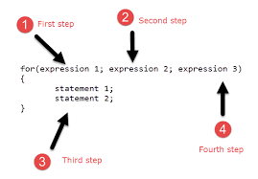

# For loop

**Example #1:**

**Write a function show that display counting from 1 to 10**

|  |
| --- |
| **Solution** |
|  |
| **The code produces the following output** |
|  |

**Example #2:**

**Write a function named “total_Digits” that return total number of digits in a number.**

|  |
| --- |
| **Solution** |
|  |
| **The code produces the following output** |
|  |

**Example #3:**

Write a procedure that prompts the user to input length of Fibonacci series and display the series.

|  |
| --- |
| **Solution** |
|  |
| **The code produces the following output** |
|  |

**Challenge#1:**

Find the frequency of a digit in a number.

**Challenge#2:**

Write a program that prompt the user to enter a number, program should display the factorial of that number.

Congratulations, you have performed all the tasks using the For Loop

.

**While Loop:**

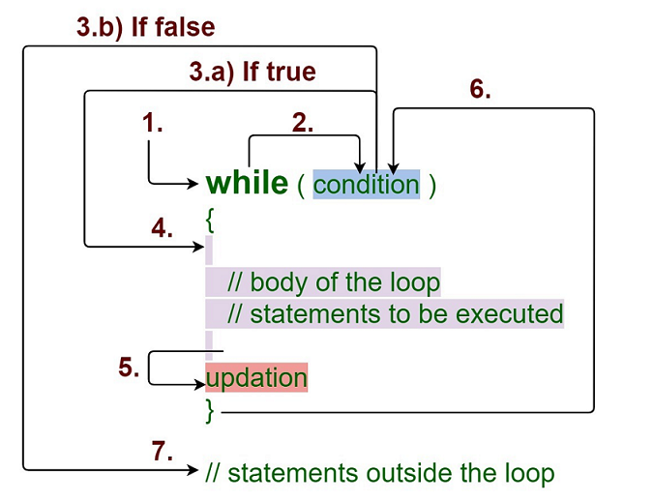

A **while** loop statement repeatedly executes a target statement as long as a given condition is true.

## Syntax

The syntax of a while loop in C++ is

while(condition) {

statement(s);

}

Here, **statement(s)** may be a single statement or a block of statements. The **condition** may be any expression, and true is any non-zero value. The loop iterates while the condition is true.

When the condition becomes false, program control passes to the line immediately following the loop.

**Example #1:**

**Print a message “I am happy” until user press “y” or any key to exit.**

|  |
| --- |
| **Solution** |
|  |
| **The code produces the following output** |
|  |

**Example #2:**

**Write a program that checks whether the number is palindrome or not.**

Palindrome number is such number which when reversed is equal to the original number. For example: 121, 12321, 1001 etc.

|  |
| --- |
| **Solution** |
|  |
| **The code produces the following output** |
|  |

**Example #3:**

## C++ Program to convert Octal to decimal number using while loop

|  |
| --- |
| **Solution** |
|  |
| **The code produces the following output** |
|  |

**Congratulations, you have practiced and learned the fundamental concepts of While Loop.**

**Let's start the challenges now.**

**Challenge 1:**

Write a program to find greatest common divisor (GCD) or highest common factor (HCF) of given two numbers.

|  |
| --- |
| **Solution** |
|  |
|  |

**Nested For Loop:**

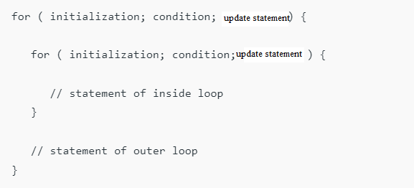

A **nested loop** has one loop inside of another. These are typically used for working with two dimensions such as printing stars in rows and columns as shown below. When a loop is nested inside another loop, the inner loop runs many times inside the outer loop. In each iteration of the outer loop, the inner loop will be re-started. The inner loop must finish all of its iterations before the outer loop can continue to its next iteration.

**Example #1** Write a program in C to display the pattern like right angle triangle using an asterisk.

*

* *

* * *

* * * *

* * * * *

|  |
| --- |
| **Solution** |
| **With Nested For** |
|  |
| **The code produces the following output** |
|  |
| **The code produces the following output** |

**Example#2:** Write a program in C to make such a pattern like a pyramid with a number which will repeat the number in the same row.

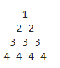

|  |
| --- |
| **Solution** |
| **With Nested For** |
|  |
| **The code produces the following output** |
|  |
| **The code produces the following output** |

**Example#3**

**Write a program to compute sinx for given x. The user should supply x and a positive integer n. We compute the sine of x using the series and the computation should use all terms in the series up through the term involving xn**

|  |
| --- |
| **Solution** |
| **With Nested For** |
|  |
| **The code produces the following output** |
|  |

Challenge#1: Write a program in C to display the pattern like diamond using an asterisk.

